Yes You Need More Subnetting Task
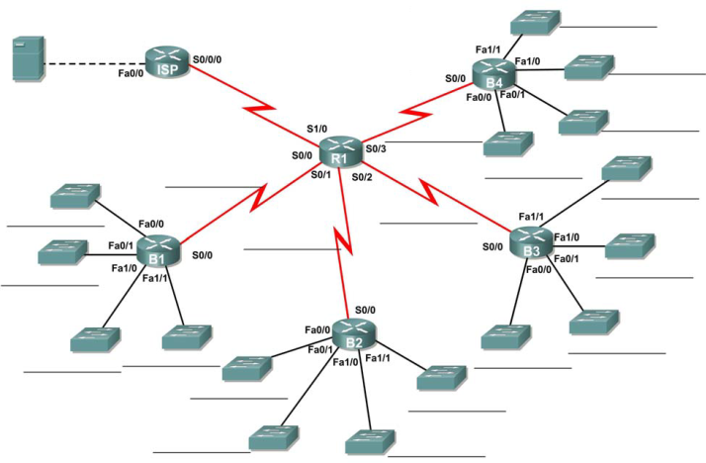
- You have been given the above topology diagram that you need to create. Subnet the network address of 10.1.2.0 that has a subnet mask of 255.255.255.0 so that any subnet can have up to 6 useable hosts (this includes the router interfaces in this number).
Complete the subnetting exercise and fill in the below table.

Subnet | Network Address | First Useable Host | Last Useable Host | Broadcast Address
R1–ISP – WAN
R1–B1 – WAN
R1–B2 – WAN
R1–B3 – WAN
R1–B4 – WAN
ISP – Fa0/0 – LAN
B1 – Fa0/0 – LAN
B1 – Fa0/1 – LAN
B1 – Fa1/0 – LAN
B1 – Fa1/1 – LAN
B2 – Fa0/0 – LAN
B2 – Fa0/1 – LAN
B2 – Fa1/0 – LAN
B2 – Fa1/1 – LAN
B3 – Fa0/0 – LAN
B3 – Fa0/1 – LAN
B3 – Fa1/0 – LAN
B3 – Fa1/1 – LAN
B4 – Fa0/0 – LAN
B4 – Fa0/1 – LAN
B4 – Fa1/0 – LAN
B4 – Fa1/1 – LAN

- Set up a new Packet Tracer file and have a go at creating the above topology. Best to use “2621XM” routers and add in whatever modules you need, according to the topology. You will need to experiment with the interface modules. Attach a PC to each switch in the topology. This requires doing some things that are new and so feel free to ask for help.

- Configure all the interfaces with the correct IP addresses. Use the last useable IP address in each subnet for the router interface (this will also be the default gateway for the PC), use the first useable IP address in each subnet for the PC’s interface. Once completed you should be able to ping each router from the PC in the same network.

- Have a go at the same challenge that I put forward last week. See if you can get the WAN links working so that you can ping from router to router. Now how far can you ping from each PC? Why can you not ping any further? Now just like last week, see if you can work out how to get all interfaces pinging from one end of the topology to the other. A reminder that this is a fun challenge and is beyond the scope of CCNA1 and so don’t worry if you cannot do this.

